ADDITION PROBLEMS
KS1 – 2001 Paper
1.
15, 25 and 35

2.
3 more fives.
So: 5 + 5 + 5 + 5 + 5 = 25

3.
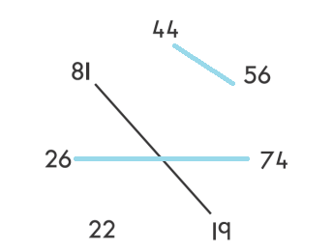

4.
136
KS1 – 2002 Papers
5.
6.
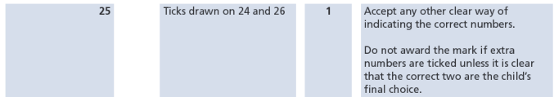
7.
KS1 – 2003 Paper 1
8.
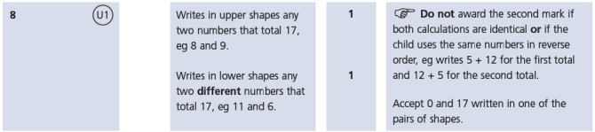
KS1 – 2005 Paper 1
9.
One example: 13+7+3=23 etc.

KS1 – 2007 Paper 1
10.
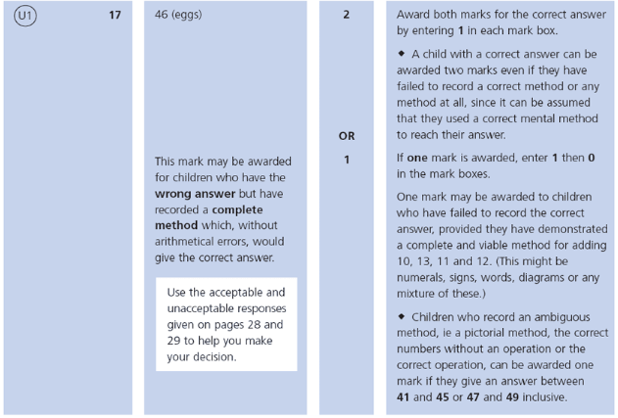
KS1 – 2007 Paper 2
11.
KS1 – 2009 Paper 1
12.
13.
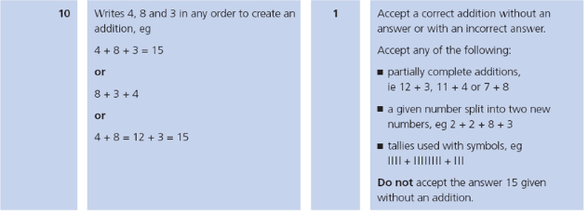
14.
KS1 – 2016 Paper - Reasoning
15.
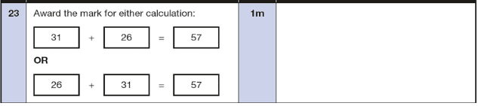
KS1 – 2016 Paper - Arithmetic (Second)
16.
KS1 – 2016 Paper – Reasoning (Second)
17.
18.
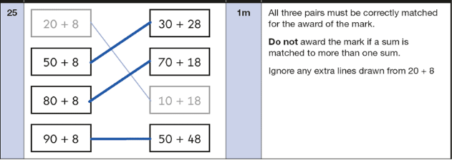
KS1 – 2017 Paper – Arithmetic
19.
KS1 – 2017 Paper – Reasoning
20.
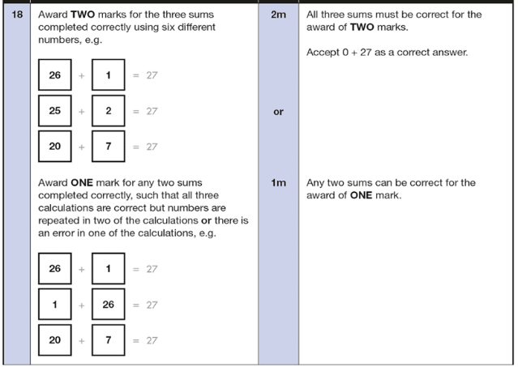
21.
22.
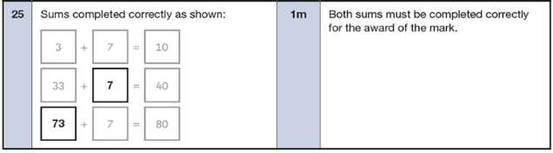
KS1 – 2018 Paper – Reasoning
23.
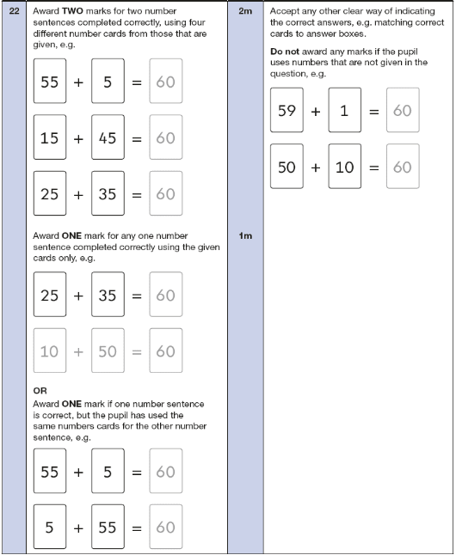
KS1 – 2019 Paper – Reasoning
24.
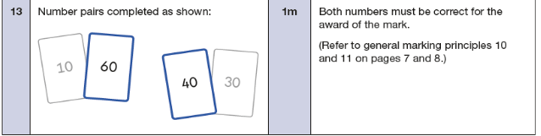
KS1 – 2022 Paper – Arithmetic
25.
KS1 – 2022 Paper – Reasoning
26.
27.
28.
